Aaron Templeton

U0734119

CS 3200

Assignment 4

1a) see code file

1b) see code file

1c)

Graphs below are as follows:

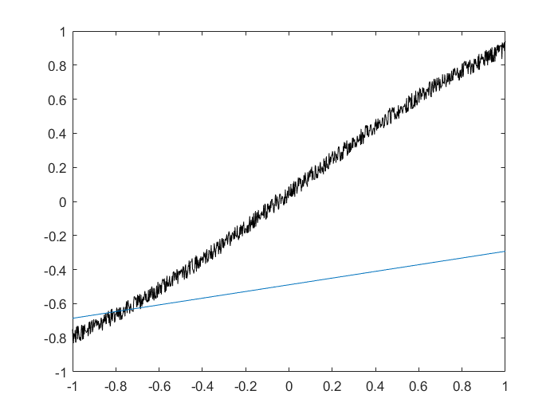N=3, l=2 N=3, l=1

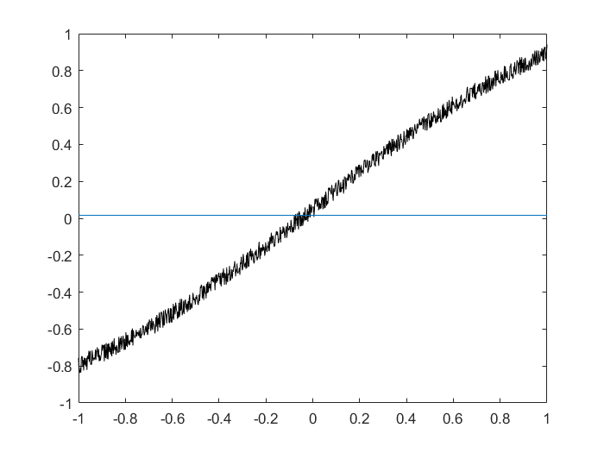

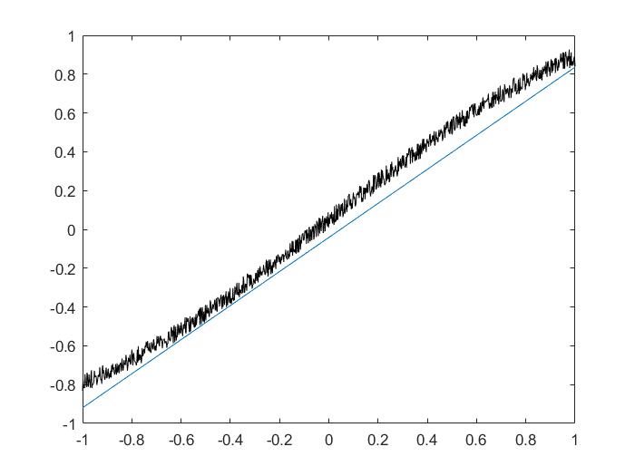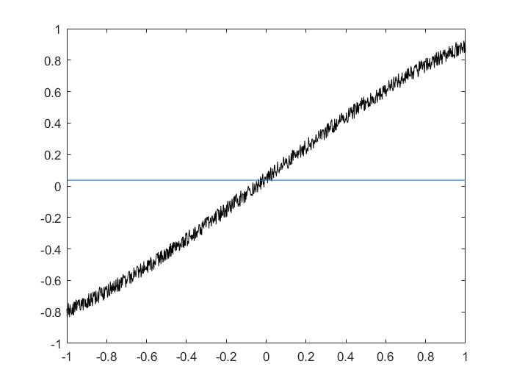N=10, l=1 N=10, l=2 N=10, l=9

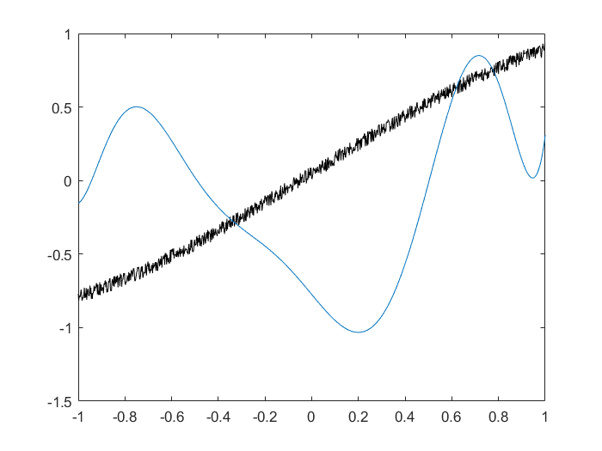

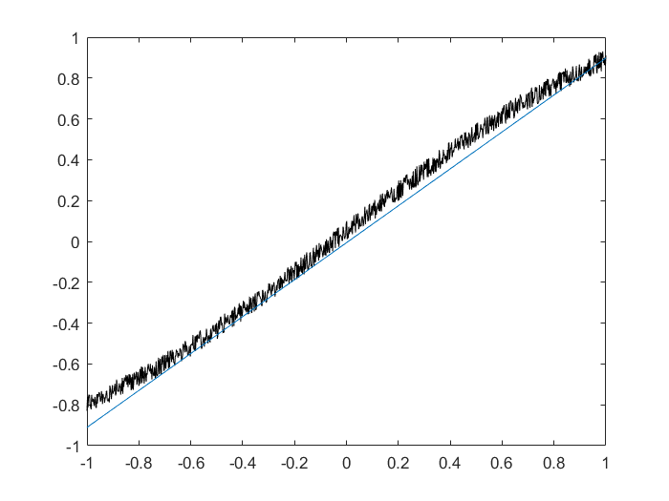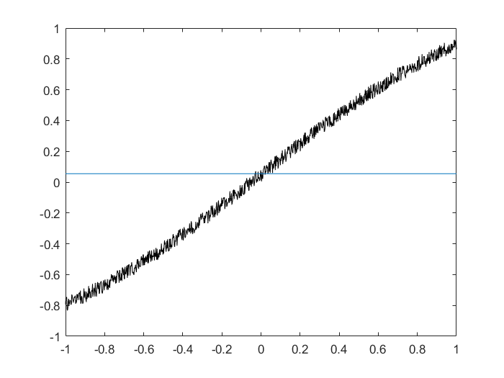N=40,l=1 N=40,l=2 N=40,l=39

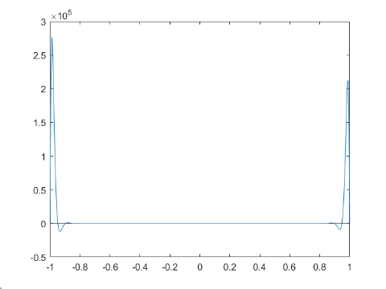

The closer L is to N, the better fit the graph is. If L is very far from N, the fit will not be accurate

1d) relative error should be measured against f(x). you should account for noise in data